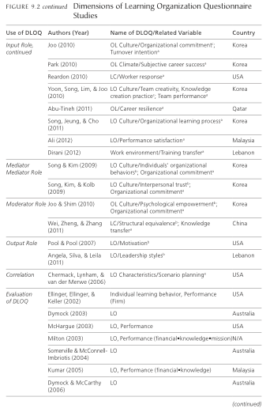

Swanson, R.A. & Chermack, T.J. (2013). Theory building in applied disciplines.

San Francisco: Berrett-Koehler, p 147.